Apache Hive



History of Hive

What is Hive

How & when hive can be used

When hive cannot be used hive architrctutre

Présenté par : Mounir Ben Romdhane



Saving Life

before

after

Mr hadoop

Ms hive

whose idea was it ??

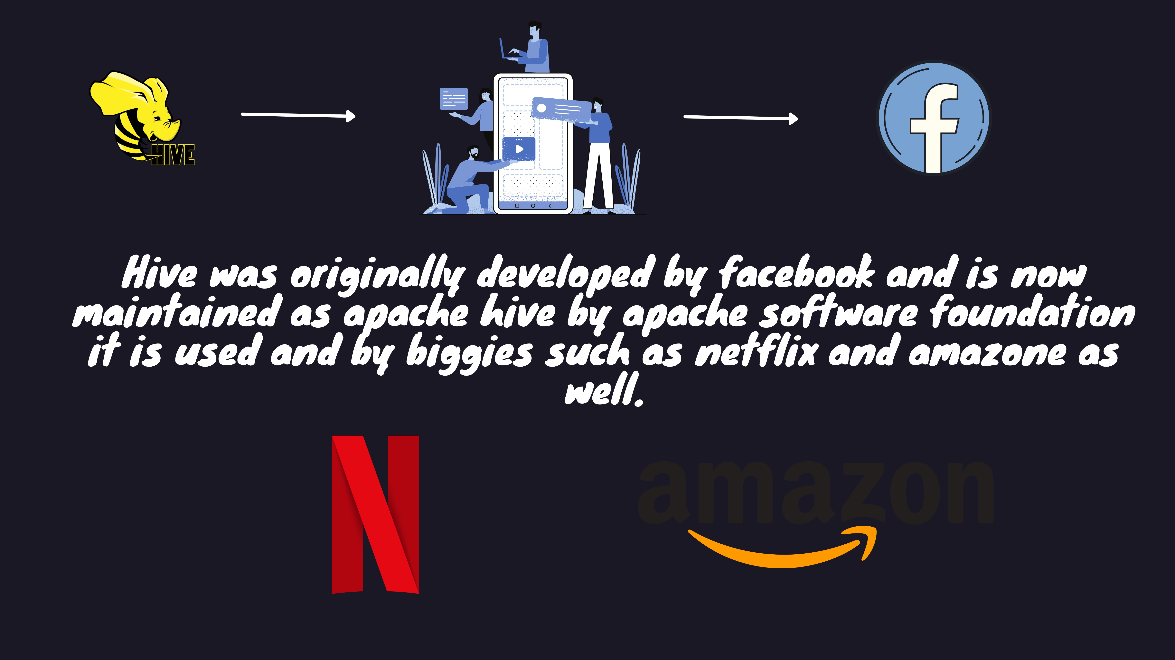

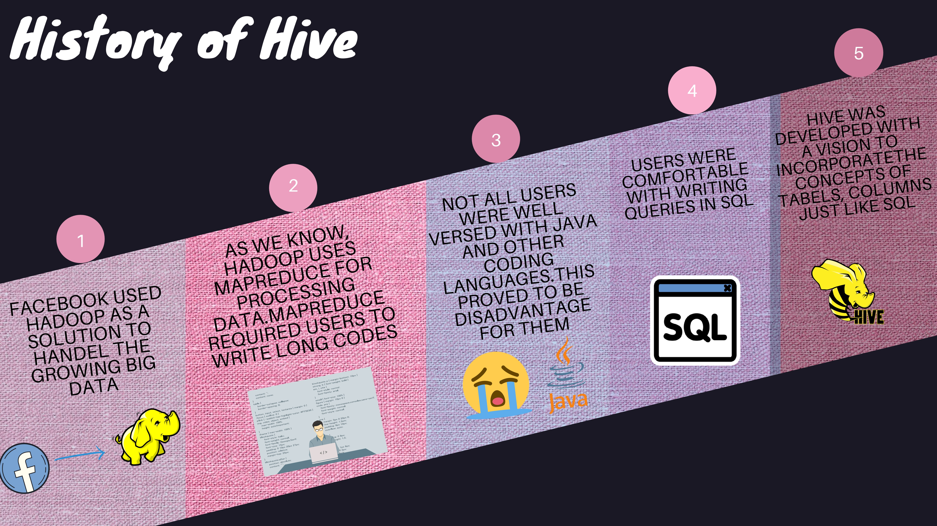

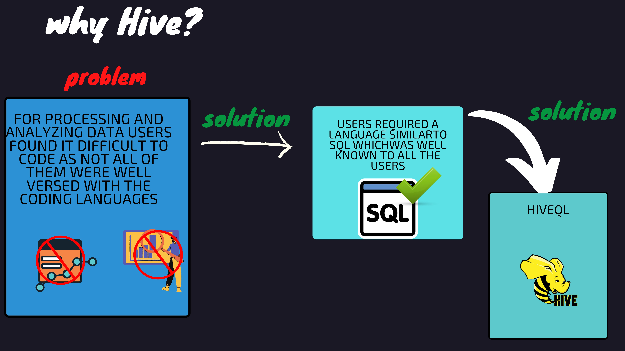

what is hive?

Apache Hive is a datawarehouse for Hadoop. It was created by

Facebook to later become an open source Apache project. This is not a relational database or a classic data warehouse.

If Hive is not a database or a data warehouse, then what is it?

This is a system that maintains metadata describing data

stored in HDFS. It uses a relational database called metastore (Derby by default) to ensure metadata persistence. Thus, a table in Hive is essentially composed:

From a diagram stored in the metastore,

Data stored in HDFS

How & when hive can be used ?

Hive can be used for it is scalable, fast t is a great platform OLAP (online and flexible. for the SQL users to

 processing)analitique write SQL like queriesto interact with thelarge datasets thatreside on HDFSfilesystem

Here is what Hive cannot be used for:

It is not a for scenarios whereIt cannot be used relationaldatabase used for OLTPIt cannot be(online used for realIt cannot be expected, becauselow latency dataretrieval is



transaction)processing time updatesor queries there is a latencyin converting the

HIVE scripts into

MAP REDUCE scripts by Hive

Some of the finest features of hive:

It supports

different file formats like

sequence file, text file, avro file

# format, ORC file, RC file

Metadata gets

stored in RDBMS like

derby database

Hive provides lot of compression

techniques, queries

on the compressed

data such as

SNAPPY

compression, gzip compression Users can write SQL like queries that

hive converts into

mapreduce or tez or spark jobs to query

against hadoop datasets

Users can plugin

mapreduce scripts into the hive

queries using UDF

# user defined functions

HIVE

Vs

Traditional

RDBMS

hive TRADITIONAL RDBMS

## SCHEMA ON READ SCHEMA ON WRITE

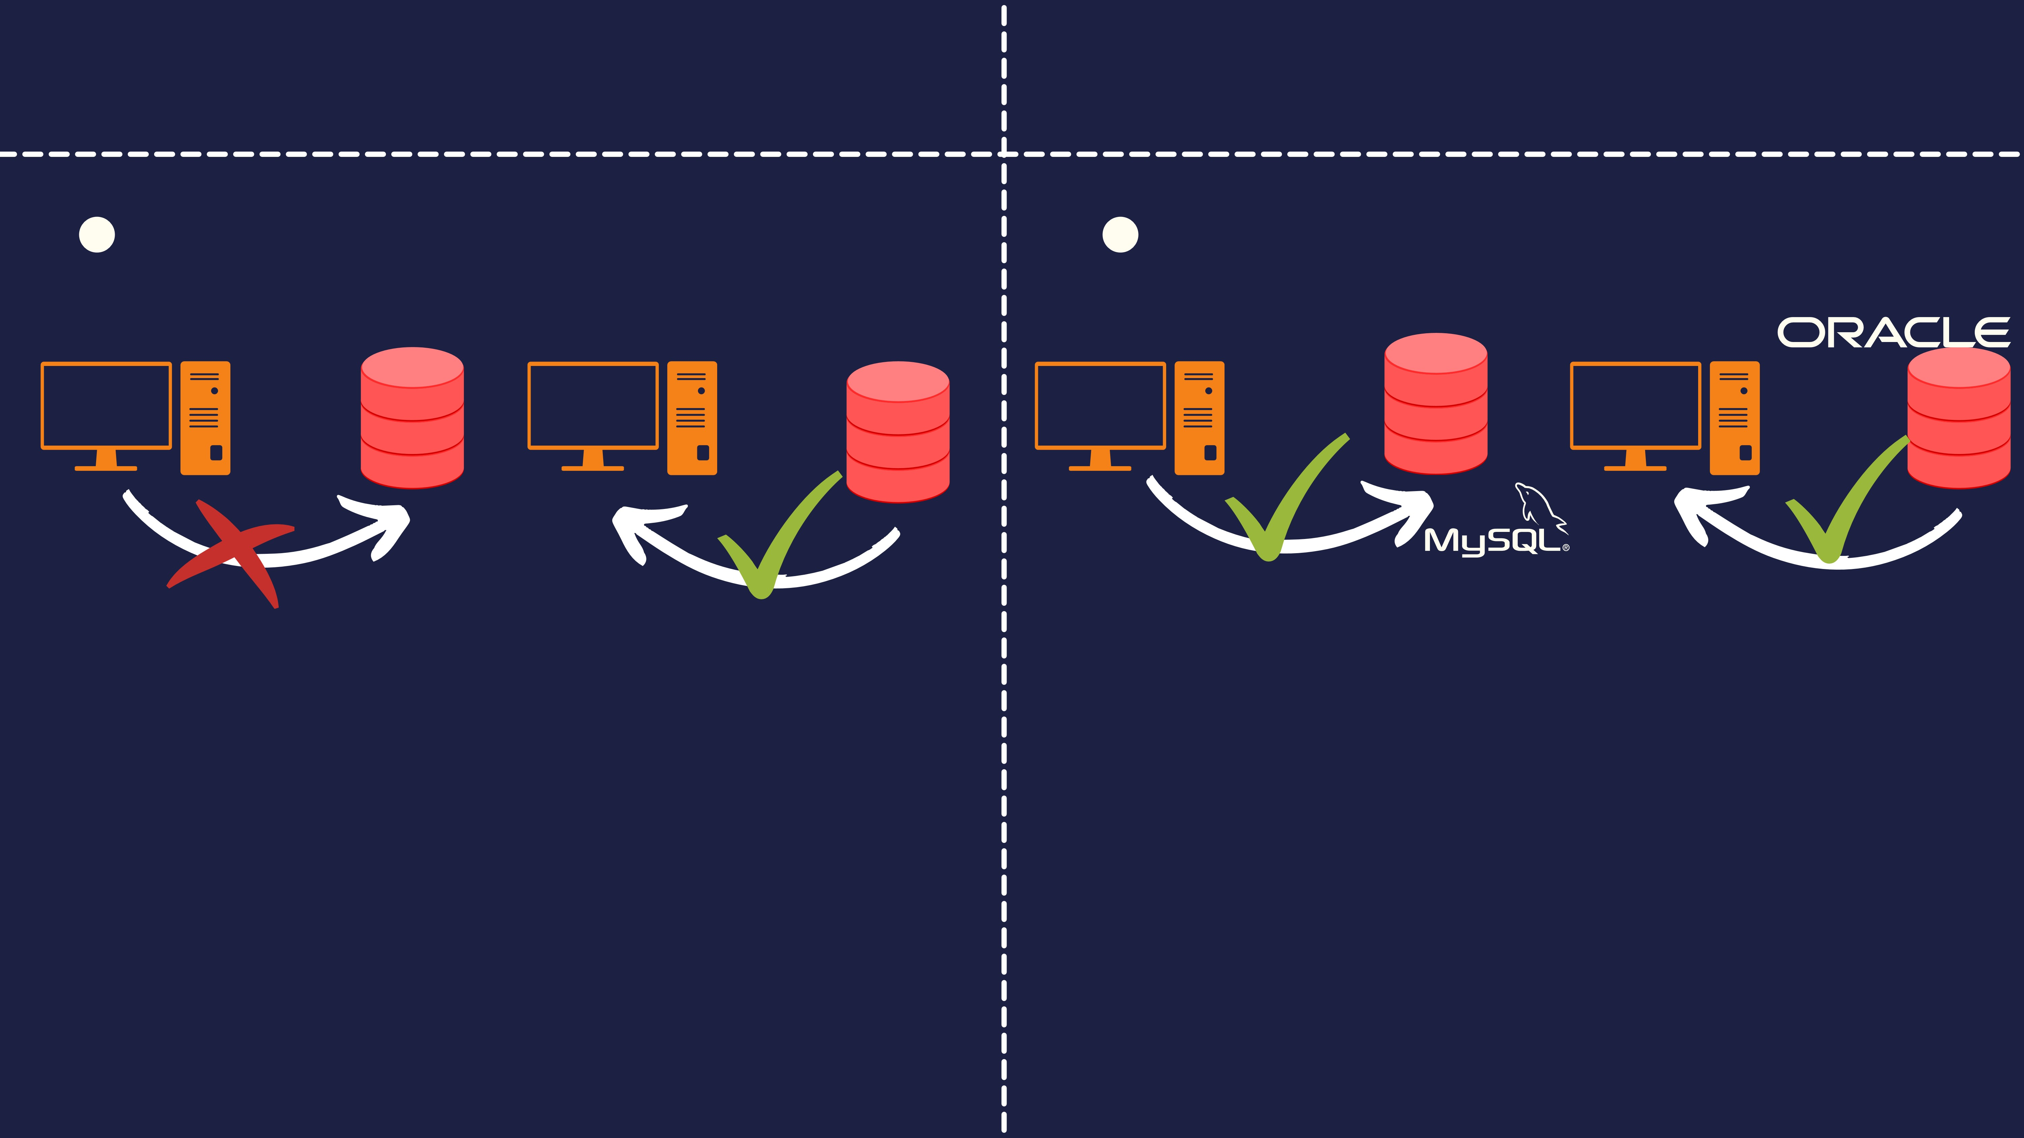HIVE ENFORCES SCHEMA ON READ TRADITIONAL RDBMS ENFORCES SCHEMA SCHEMA ON READ ALLOWS THE ON WRITE. SCHEMA ON WRITE INCLUDES

COMPONENTS TO INSERT DATA VERIFYING IF THE DATA INSERTED AS PER

WHITHOUT CHECKING FOR THE TYPE OR THE TABLE DEFINITION AND SCHEMA

SCHEMA DEFENITION OF THE TABLE IT DEFINITION DURING THE WRITE PHASE

VERIFIES THE DATA ONLY WHEN DATA IS ITSELF THIS IS HOW OUR DBMS

READ FROM THE TABLE DATABASES LIKE MYSQL ORACLE

## hive

HIVE ALLOWS YOU TO STORE

HUNDREDS OF PETABYTES OF DATA

BECAUSE HIVE STORES DATA IN HDFS WICH HAS A SCALABLE STORAGE SPACE.

DOESN'T SUPPORT OLTP

## TRADITIONAL RDBMS

DBMS HAVE A MAC STORAGE

CAPACITY AROUND 10 TERABYTES OF DATA AND QUERING SUCH LARGE DATA IS NOT AN EASY TASK.

SUPPORTS OLTP

HIVE ARCHITECTURE

